1) 10 packets transmitted, 10 received, 0% packet loss, time 1834ms
rtt min/avg/max/mdev = 0.359/0.447/0.487/0.045 ms

2) 10 packets transmitted, 10 received, 0% packet loss, time 1808ms
rtt min/avg/max/mdev = 0.373/0.484/0.621/0.075 ms

3)100 packets transmitted, 100 received, 0% packet loss, time 109ms
rtt min/avg/max/mdev = 0.331/0.433/0.584/0.059 ms
min is shortest for round trip time for a packet, while max is longest, representing best case and worst case latency. Average is calculated over 100 packets

4)10000 packet transmitted, 10000 received, 0% packet loss, time 4114ms
rtt min/avg/max/mdev = 0.284/0.375/0.707/0.046 ms, ipf/ewma 0.411/0.414ms

5)

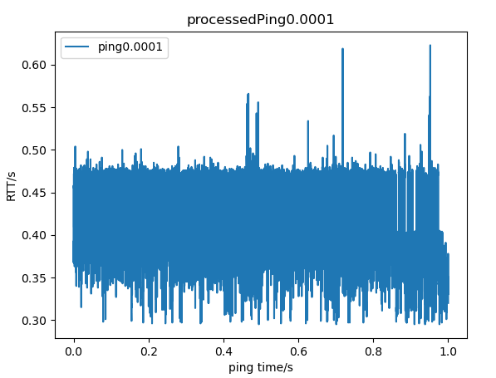

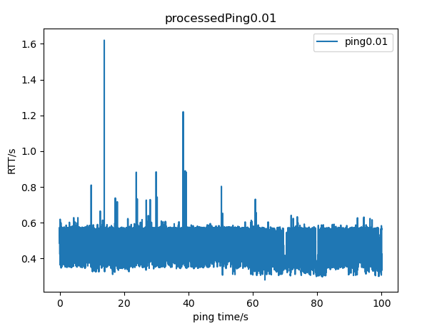
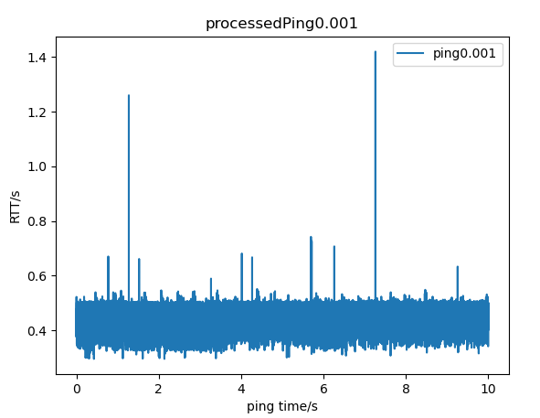

6)When the interval between packets is very short, the network may become congested, leading to increased delays and higher RTT values
The average is the most accurate as it remove the influence of individual fluctuations.

